Jack Johnson

August 4, 2021

Practice Project: Team Budget Planner

Link to my GitHub repository: <https://github.com/jjohn98/2058519_Jack_Johnson_Mean_Stack>

This project is located in ~/Phase1/Budget Planner Project.

In this project, I created four files. The first file is the home page, which links to the other two pages, the program manager page and the finance teams page. The program manager page handles accepting inputs for client name, project name, and the budget amount. This page also links back to the original page. The finance teams page then shows all of the information input into the program manager page. This page also links back to the original page. All of the JavaScript code is located in BudgetPlanner.js, the fourth file. Data is transferred over using localStorage. I first take the data from the user and store it as a JSON object. Then, I stringify this object and concatenate it onto the master string. During this, I also keep and running total of all of the budgets entered. This is also sent to a string and stored in localStorage. Then after moving to the finance teams page, the master string is split using the split() function. I then iterate through the array using a for loop and dynamically create a table based on the data entered. I also display the total amount at the bottom of the page. Bootstrap is used to help make everything slightly prettier.

Screenshot of Web pages created:

**Home.html:**



**ProgramMangerPage.html:**

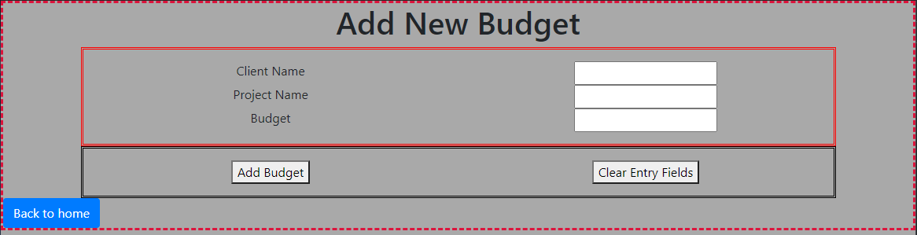

**FinanceTeamsPage.html:**

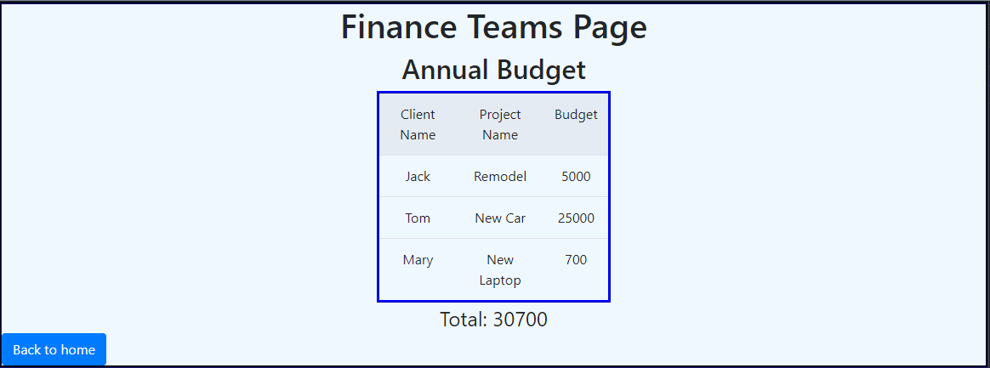

The files for this project will be in the GitHub repository, as well as the source code section of the submission on Simplilearn.